University Curriculum Committee

Proposal for New Course

1. Is this course being proposed for Liberal Studies designation? Yes No 
If yes, route completed form to Liberal Studies.
2. New course effective beginning what term and year? (ex. Spring 2008, Summer 2008) |  |  |  |  |  |  |  |  |  |  |  |  |  |  |  |  |  |  |  |  |  |  |  |  |  |  |  |  | Fall 2007
See effective dates schedule.
3. College |  | SBS |  |  |  |  |  |  |  |  | 4. Academic Unit |  |  |  |  |  |  |  |  |  |  |  |  |  |  |  | Anthropology
5. Course subject/catalog number |  |  |  |  |  | ANT 340 |  |  |  |  |  |  |  |  |  |  |  |  |  |  |  |  | 6. Units |  |  |  |  |  |  |  | 3
7. Co-convened with |  |  |  | N/A |  |  |  |  |  |  |  |  |  |  |  |  |  |  |  |  |  |  |  | 7a. Date approved by UGC
(Must be approved by UGC prior to bringing to UCC. Both course syllabi must be presented.)

8. Cross-listed with |  |  | N/A
(Please submit a single cross-listed syllabus that will be used for all cross-listed courses.)
9. Long course title |  |  | Music in Culture
(max 100 characters including spaces)
10. Short course title (max. 30 characters including spaces) |  |  |  |  |  |  |  |  |  |  |  |  |  |  |  |  |  |  | Music in Culture
11. Catalog course description (max. 30 words, excluding requisites).
This is a course in ethnomusicology—the anthropology of music, focusing on what music means to different peoples worldwide. Students will compare musical forms, approaches, and uses cross-culturally.

12. Grading option: Letter grade |  |  |  |  |  |  |  |  |  | Pass/Fail |  |  |  |  |  |  |  |  |  | or Both
(If both, the course may only be offered one way for each respective section.)
13. Is this a topics course? Yes No 
14. May course be repeated for additional units? |  |  |  |  |  |  |  |  |  |  |  |  |  |  |  |  |  | yes |  |  |  |  |  |  | no |  | 
a. If yes, maximum units allowed?
b. If yes, may course be repeated for additional units in the same term? (ex. PES 100) |  |  |  |  |  |  |  |  |  |  |  |  |  |  |  |  |  |  |  |  |  |  |  |  |  |  |  |  |  |  |  | yes |  |  |  | no
15. Please check ONE of the following that most appropriately describes the course:
Lecture w/0 unit embedded lab |  |  |  |  |  |  |  |  |  |  |  |  |  | Lecture only  |  |  |  |  |  |  |  | Lab only |  |  |  |  |  |  | Clinical |  |  |  |  |  | Research
Seminar |  |  |  |  | Field Studies |  |  |  |  |  |  |  |  |  | Independent Study |  |  |  |  |  |  |  |  |  |  |  |  |  | Activity |  |  |  |  | Supervision
16. Prerequisites (must be completed before proposed course) |  |  |  |  |  |  |  |  |  |  |  |  |  |  |  |  | None
17. Corequisites (must be completed with proposed course) |  |  |  |  |  |  |  |  |  |  |  |  |  |  |  |  | None
18. If course has no requisites, will all sections of the course require (If course has pre or co requisite, skip to question 19):
 | instructor consent |  |  |  |  |  |  |  | department consent |  |  |  |  |  |  |  |  |  |  |  |  |  |  |  |  | no consent 

19. Is the course needed for a plan of study (major, minor, certificate)? yes |  |  |  |  |  |  |  |  |  |  | no |  |  |  |  | 
Name of new plan?
Note: A new plan or plan change form must be submitted with this request.
20. Does course duplicate content of existing courses within or outside of your college? yes |  |  |  |  |  |  |  |  |  |  |  |  |  |  | no |  |  |  | 
If yes, list any courses this course may have duplicative material with and estimate percentage of duplication:
N/A
Please attach letters of support from each department whose course is listed above.
21. Will this course affect other academic plans, academic units, or enrollment? yes |  |  |  |  |  |  |  |  |  |  |  |  |  |  |  |  |  |  |  | no |  |  |  |  | 
If yes, explain in justification and provide supporting documentation from the affected departments.
22. Is a potential equivalent course offered at a community college (lower division only)? yes |  |  |  |  |  |  |  |  |  |  |  |  |  |  | no |  |  |  | 
If yes, does it require listing in the Course Equivalency Guide? yes |  |  |  |  |  |  |  |  | no |  |  |  |  |  |  |  | N/A
Please list, if known, the institution, subject/catalog number of the course. |  |  |  |  |  |  |  | N/A
23. Justification for new course, including unique features if applicable. (Attach proposed syllabus in the approved
university format).

Music is a major culture component. As such, a course on music in culture is a valuable addition to any Anthropology program. This is the only course on music in culture (ethnomusicology) to be offered by the Department of Anthropology. It has been well-received by students the past two spring semesters.

24. Names of current faculty qualified to teach this course |  |  | Scott Antes, James Wilce
25. If course will require additional faculty, space, or equipment, how will these requirements be satisfied? N/A
26. Will present library holdings support this course? yes |  |  |  | no

If the course being submitted for approval is NOT a LIBERAL STUDIES course, please go to step 42.

LIBERAL STUDIES ONLY

Contact name: Contact email:
Dept. Chair name: Dept. Chair email:
College Contact name : College Contact email:

27. This course is a Single section Multi-section
28. List names of faculty who may teach this course:
29. Section enrollment cap:

If this course is being submitted for approval as a new LIBERAL STUDIES course, please complete questions 30-33.
OR
If this course is being submitted for approval as a new JUNIOR LEVEL WRITING course, please complete questions 37-38.
OR
If this course is being submitted for approval as a new SENIOR CAPSTONE course, please complete questions 39-41.

NEW LIBERAL STUDIES COURSE
30. Thematic Focus (check all that apply): If a topics course, must apply to ALL sections.
Environmental Consciousness Technology and Its Impact Valuing the Diversity of Human Experience

31. Distribution Block (check one): If a topics course, must apply to ALL sections.
Aesthetic and Humanistic Inquiry Cultural Understanding Lab Science
Science/Applied Science Social and Political Worlds

32. Skills (check two): If a topics course, must apply to ALL sections.

Creative Thinking Critical Reading Effective Oral Communication Effective Writing Critical Thinking
Ethical Reasoning Quantitative/Spatial Analysis Scientific Inquiry Use of Technology

33. Is this a topics course? Yes No
If YES, please complete questions 34-36. If NO, please go to question 42.

TOPICS COURSE ONLY
34. Identify the Student Learning Outcomes that will be found in ALL topic syllabi offered under this course number.

35. Explain by what method(s) Student Learning Outcomes will be assessed in ALL topic syllabi offered under this course number.

36. Please attach an example of a Topic Syllabus offered under this course number.

GO TO question 42

NEW JUNIOR LEVEL WRITING COURSE (refer to question 19)

37. To which degree programs offered by your department/academic unit does this proposal apply?
38. Do you intend to offer ABC 300 and ABC 300W? yes no
If no, please submit a course delete form for the ABC 300.

GO TO question 42

NEW SENIOR CAPSTONE COURSE (refer to question 19)

39. To which degree programs offered by your department/academic unit does this proposal apply?

40. Does this proposal replace or modify an existing course or experience? yes no
If yes, which course(s)?

41. Do you intend to offer ABC 400 and ABC 400C? yes no
If no, please submit a course delete form for the ABC 400.

42. Approvals
Department Chair (if appropriate) Date
Chair of college curriculum committee Date
Dean of college Date

For Committees use only
For Liberal Studies Committee Date

Action taken:
_____________________ Approved as submitted ___________________________ Approved as modified

For University Curriculum Committee Date

Action taken:
 |  | Approved as submitted |  | Approved as modified

Course Syllabus

ANT 340 Music in Culture
NAU College of Social and Behavioral Sciences, Department of Anthropology

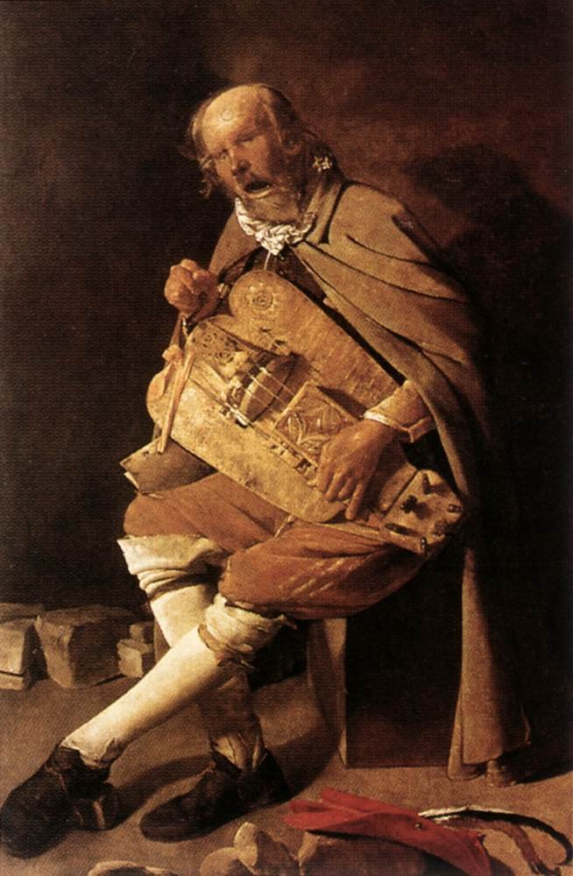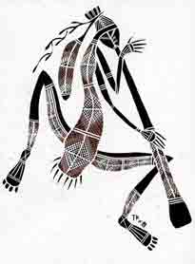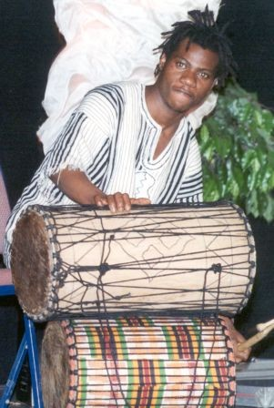

Semester Hours: 3
Meeting Times: MWF 12:40 PM-1:30 PM
Bldg. & Room: Bldg. 65, SBS 107
Instructor: Scott E. Antes, MA Phone: 523-9664
Office: Anthropology 101C (Bldg. 98D) e-mail Scott.Antes@nau.edu
Office Hours: Monday & Wednesday 11:20 AM-12:20 PM, and by Appointment

Prerequisites: None

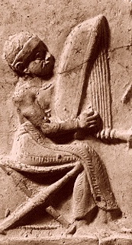
Course Description. Welcome to Music in Culture. Keep in mind that this is an anthropology course, not a music course. It’s a very focused cultural anthropology course. We’re going to talk about—and experience—a lot of music in here, but we’ll focus on the cultural and social aspects of music, rather than the technical and theoretical constructs of music. The latter you can study in a music course. This is a course in ethnomusicology—the anthropology of music. Here we’ll study what music means to different groups of people. The core of cultural anthropology, after all, is meaning, and hopefully this course will be a meaningful one for you. As cultural anthropologists, we will compare musical forms, approaches, and uses cross-culturally. Since we have just one semester in which to do all this, we’ll obviously need to concentrate our efforts on a limited number of themes, as well as selections to which we’ll listen, observe, and perhaps in which each of us will participate. We’ll take an historical approach—cross-culturally, focusing on how the functions of music have changed (or not) over time, and we’ll discuss the instruments of music in considerable depth. As we go along, we’ll study current thinking in the field of ethnomusicology.

Student Learning Expectations. The primary goals of this course are:
✵ To keep stress levels low, to keep learning and enjoyment levels high.
✵ To offer every student in the class an active, participatory role in the learning process.
✵ To provide working definitions and explanations of terms such as “anthropology,” “culture,” “music,” etc.
✵ To open a window through which students may view a variety of musical cultures from around the globe.
✵ To illustrate the differences and similarities between various cultures approaches to and uses of music, in order that the student’s cultural exposure might be coupled with cultural understanding.
✵ To stimulate an appreciation for ethnic and cultural diversity in musical forms and applications.
✵ To furnish the student with learning tools that hopefully will enable him or her to become a more effective student and better informed citizen of Planet Earth.
✵ To encourage critical thinking.

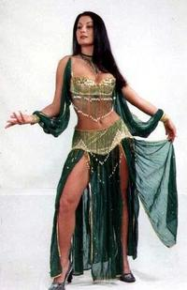
Course Structure. We will conduct this course together, as a class, in a lecture-discussion format, with an accent on student participation. Lectures will serve to summarize and supplement reading assignments, as well as to provide a framework for class discussion. Throughout the semester we also will listen to many audio recordings and view numerous performance videotapes. Hopefully we’ll enjoy a number of live in-class performances. Students must compose ten short weekly essays, write a critical book or performance review and present it to the class, take two examinations (midterm and final), and participate to the extent they are willing and able. (See “Course Requirements and Grading.”)

Required Text and Readings (available in the NAU bookstore, textbook department):
Clayton, Martin, Trevor Herbert, and Richard Middleton. 2003. The Cultural Study of Music. New York: Routledge.
Instructor's Note: Although I require just one textbook for this course, keep in mind that all videos, slide presentations, or other visual presentations shown in class are required viewing!!! Also, any guest performances are exam material.
Class handouts will supplement the above texts. Additional reading assignments may be required, at the instructor’s discretion. Any such assignments will be handed out in class, sent to the class by e-mail, placed on reserve in the library, or made available as a course pack.

Course Outline.
Readings: Students are assigned regular readings from class texts, as outlined in the “Tentative Class Schedule.” Since weekly papers and class discussion are based on these readings, students are expected to come to class prepared. Information from class handouts definitely will appear in exam questions, as will material from audiovisual and performance presentations (possibly even from this syllabus).

Weekly Writing Assignments (10 @ 4 points each = 40 possible points). See note in following paragraph!!!
This should be an easy 40 points. For each of ten weeks, students are required to submit a paper on either (a) the assigned readings for that week, (b) the visual presentation for that week, or (c) a topic of the instructor’s choice. These papers are to be one (minimum) to two pages in length. They are not to be summary papers!! Unless the instructor specifies a topic for the paper, students are simply to relate (1) what he or she found most interesting, enlightening, remarkable, amusing, bothersome, etc., to him/her in the reading, visual presentation or lecture for that week, (2) why the item struck him/her so, and (3) where the student read or discovered the item. Important: In order to receive full credit, the paper must include the what, the why, and the where. (For additional information on paper requirements, see “Course Policies.”) Papers are due by the beginning of class period on the day scheduled, and must be marked “Paper 1,” Paper 2,” etc., in order to get credit for the assignment. Note! Submit papers only on Wednesdays! Further, I will not accept papers more than one week late.

Assessment of Student Learning Outcomes.
Mid-term Exam (100 possible points).
Like the final exam, this exam probably will consist of about half multiple-choice questions, with some essay questions. As I write this syllabus, I’m thinking that your essay section will be take-home. The mid-term will encompass all material covered in class up to exam day. Note: Based on course flow, the exam format may change.

Student or Group Presentation (35 possible points). Details will be provided in class.

Final Exam (100 possible points). (Similar in format to the midterm exam, but non-comprehensive.)

Class Participation (25 possible points).
Although ANT 399 officially is a lecture-format course, in this section we emphasize active learning. In other words, everyone in this class is expected to play some participatory role in the teaching/learning process. Students will be graded based on their participation. Class participation will be measured by the frequency at which a student participates (or tries to participate) in class discussion, and by regular attendance. (See “Course Policies.”) Don’t be shy. Ask questions. Voice your opinions. This is your class.

Grading Scale:

90-100% (267-300 points): A
80-89% (237-266 points): B
70-79% (207-236 points): C
60-69% (177-206 points): D

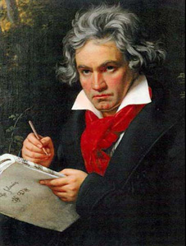
Course Policies:
•Regular attendance is mandatory!!! You’re students; it’s your job to be here. If you are absent, you very likely will lose points. If for some legitimate reason you must miss a class, it is your responsibility to inform me in advance or furnish a doctor’s note or other documentation defending your absence.

•Note-taking is essential. Examination material will come as much from class lectures as from the readings.

•Concerning papers: (a) Plagiarism will not be tolerated. Any statements--phrases of 4 words or more--taken verbatim from another author must be enclosed in quotation marks and properly referenced. (For references, use the format shown in this syllabus under “Required Text and Readings.”) (b) All papers must be typed--or printed on a computer printer, double-spaced, in 12-point fonts. Acceptable fonts are CG Times, Times New Roman, Courier 10 Pitch, Arial, or equivalents. Maximum margin settings: 1” top and bottom, 1.25 inches right and left. (c) Papers may be written in any style or format, as long as they adhere to the above specifications and are academically acceptable to your instructor. (d) Papers are to be neat and legible, with a minimum of typos, misspellings, and grammatical errors. Use your grammar and spell checkers!!!

•Special consideration will be given to students with learning disabilities, physical handicaps, or for whom English is not a first language. Please inform me now if this applies to you. Students who have learning disabilities or physical handicaps must present a copy of their eligibility letter to me as soon as possible. It may be difficult to accommodate you if special requests are made at the last minute (i.e., the day before an exam).

•Make-ups: Important: Because this is a large class, it’s very important that your papers be turned in on time, and your exams taken when scheduled. Make-ups and late papers allowed only with prior permission.

•Incompletes: Only written medical documentation constitutes reason for the issuance of an “incomplete.”

•Academic dishonesty of any kind will not be tolerated. Students charged with academic dishonesty are subject to the Arizona Board of Regents’ Code of Conduct—as well as procedures established by NAU and outlined in the NAU Student Handbook. (See attachment to this syllabus.)

•Vista: If you are reading this syllabus, you already know that we have a Vista shell for this course. Check it regularly for handouts and course information. Use Vista mail for course-related messages, to me or your fellow students. Utilize the Discussions feature, too. I’ll use Vista to send you handouts and study guides. Do not post Tasty Tidbits (you’ll see what these are later) on Vista!!!

Northern Arizona University Policy Statements: It is important that you read these. See http://jan.ucc.nau.edu/academicadmin/policy1.html.

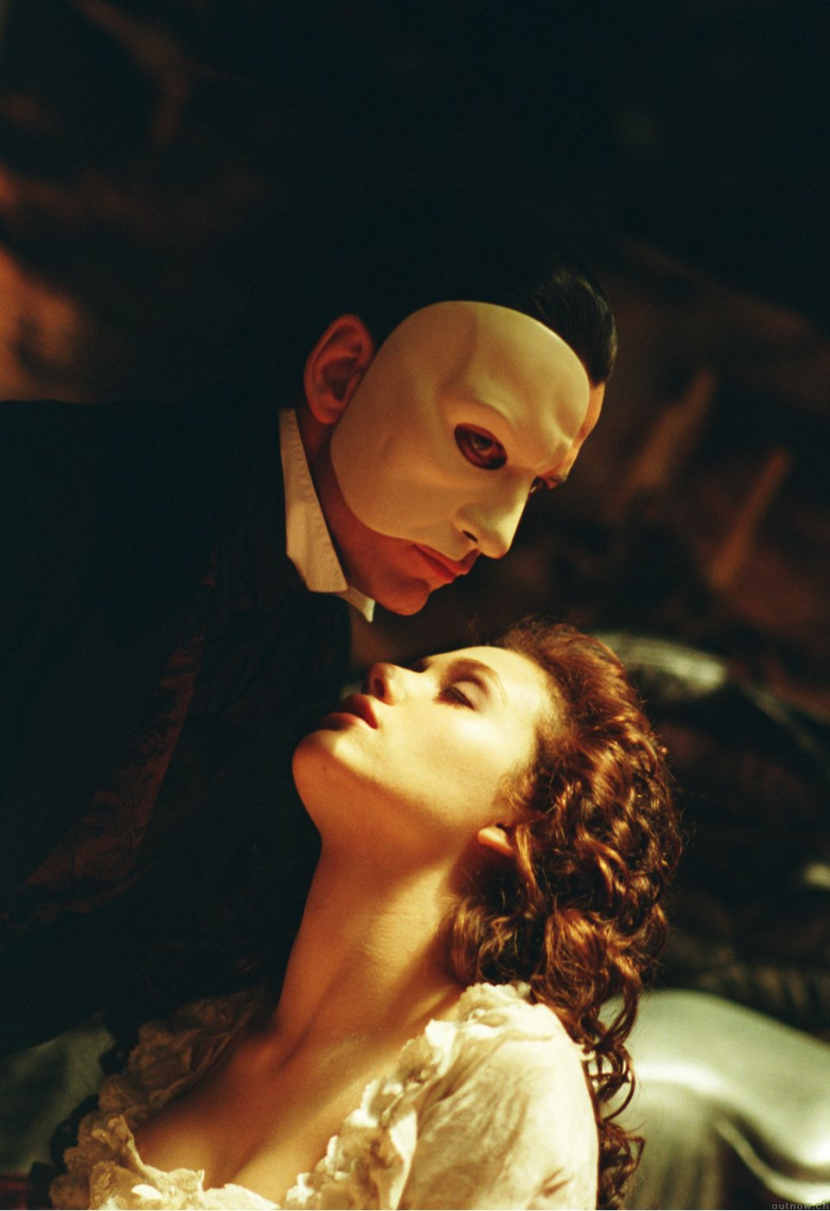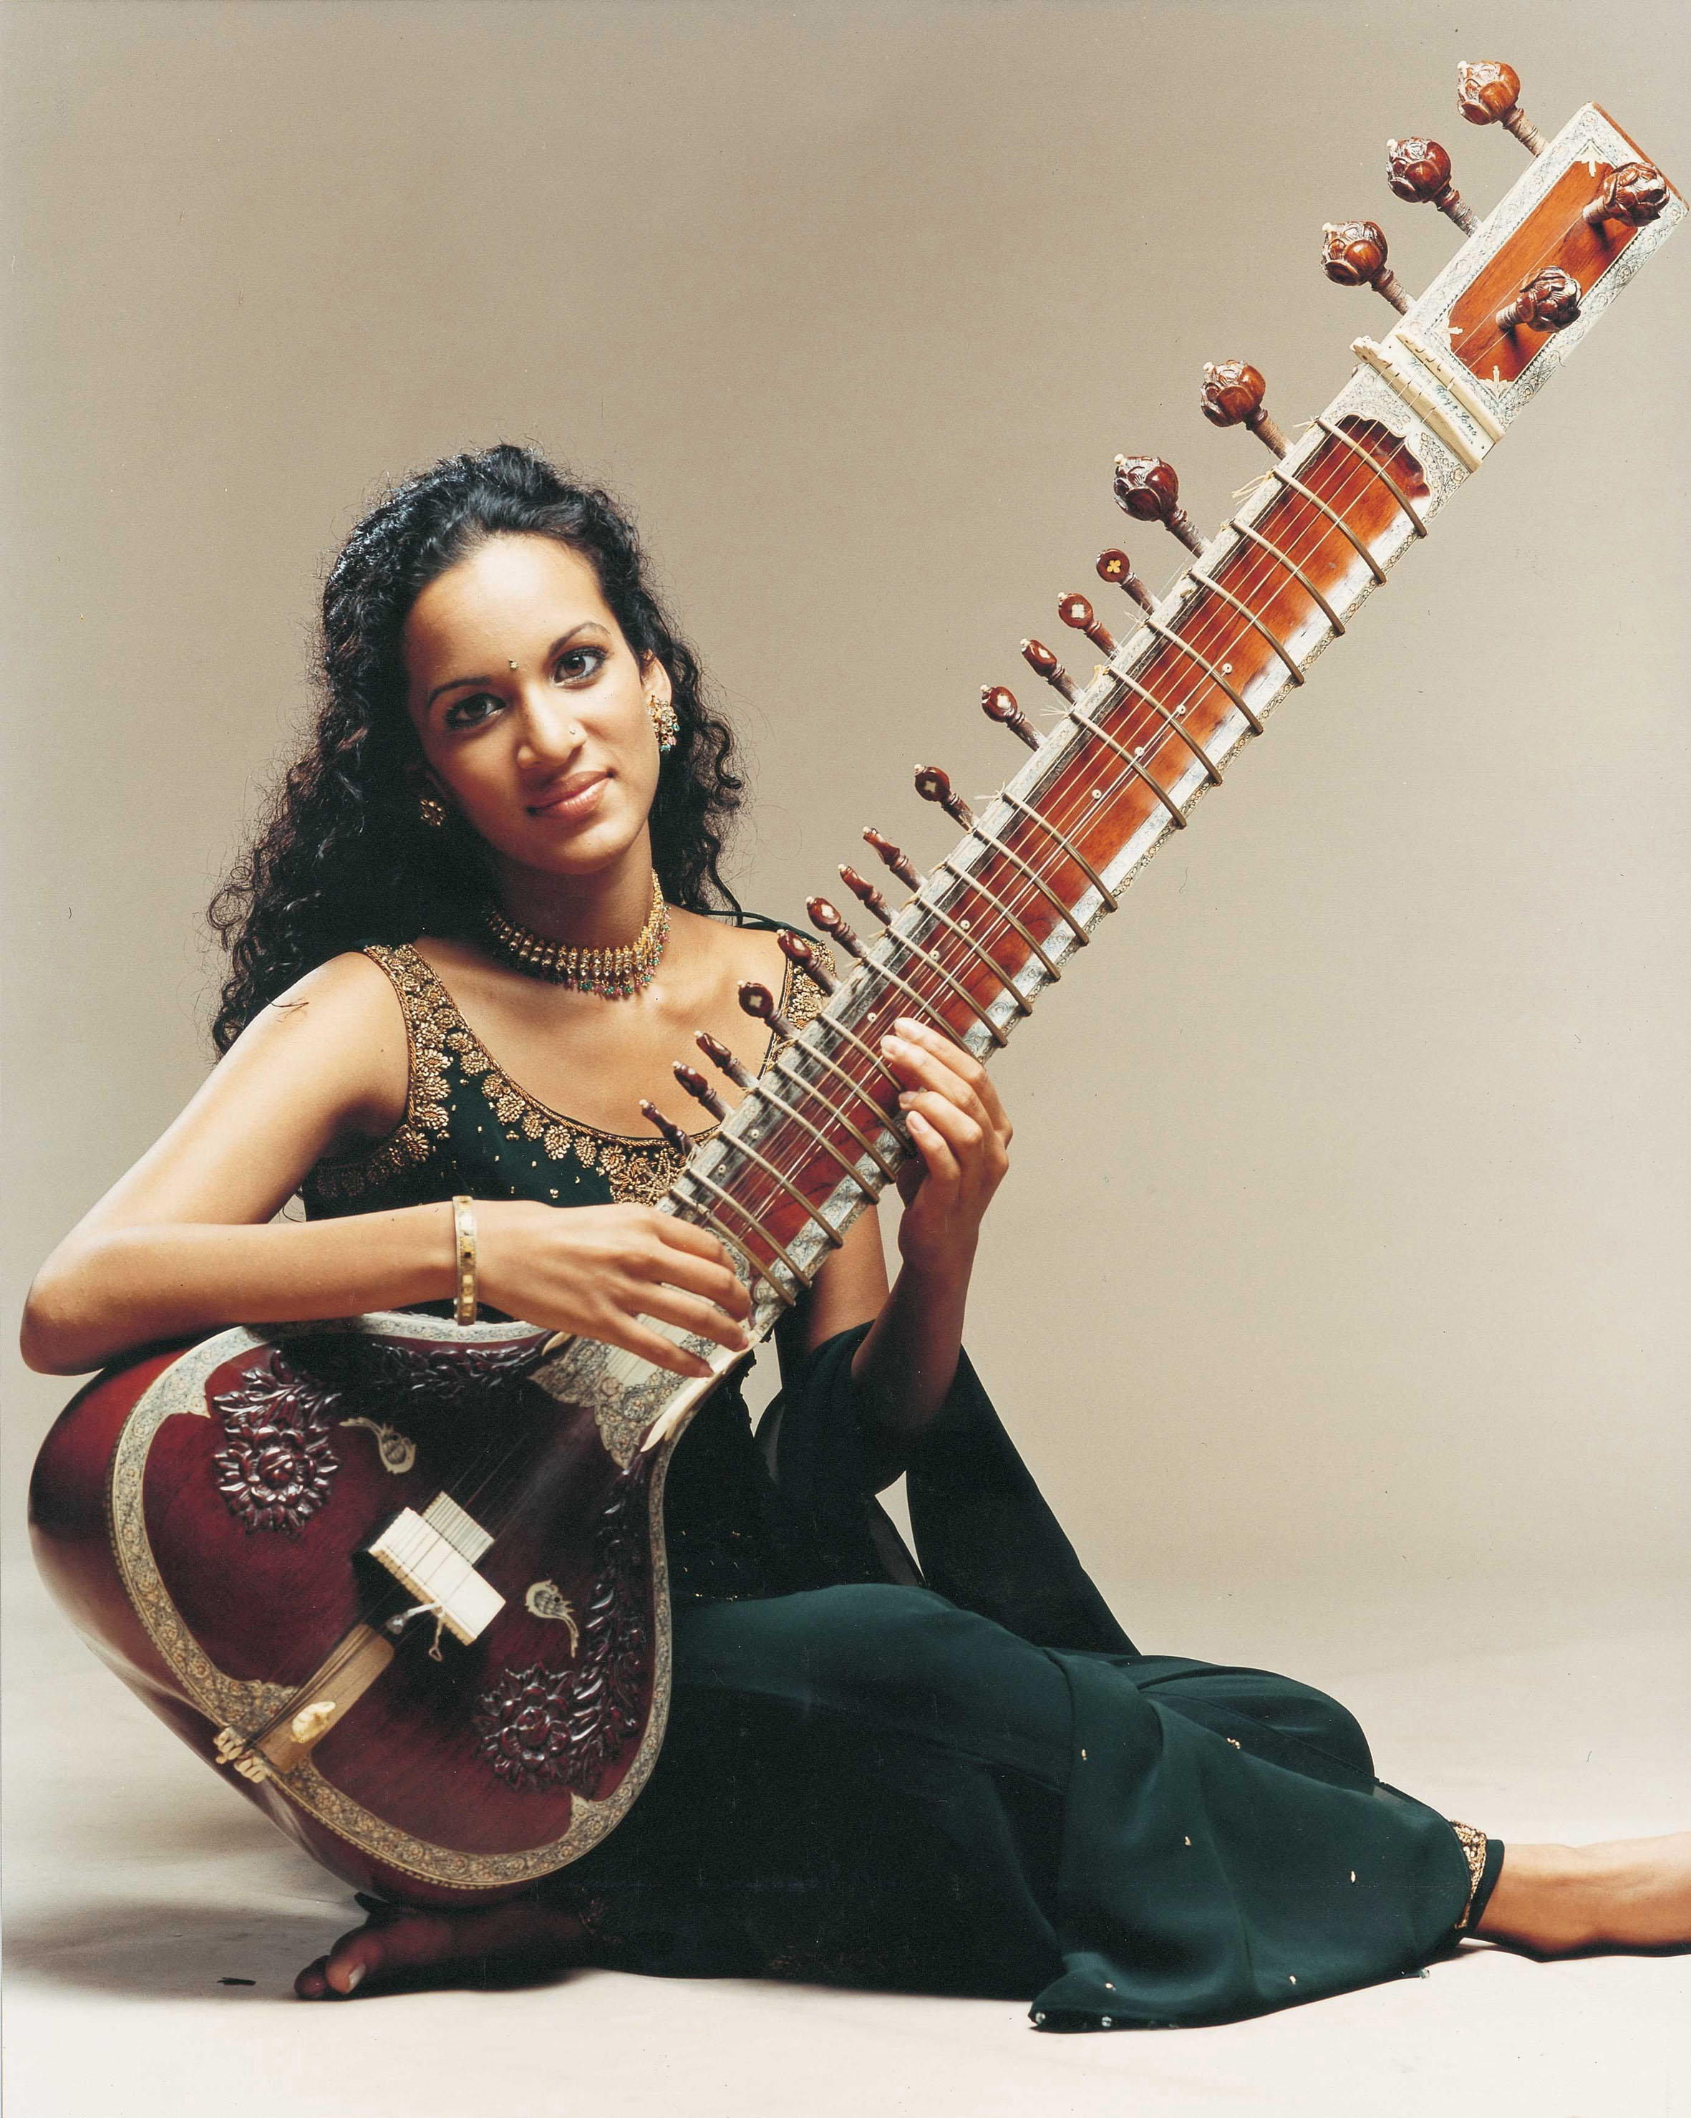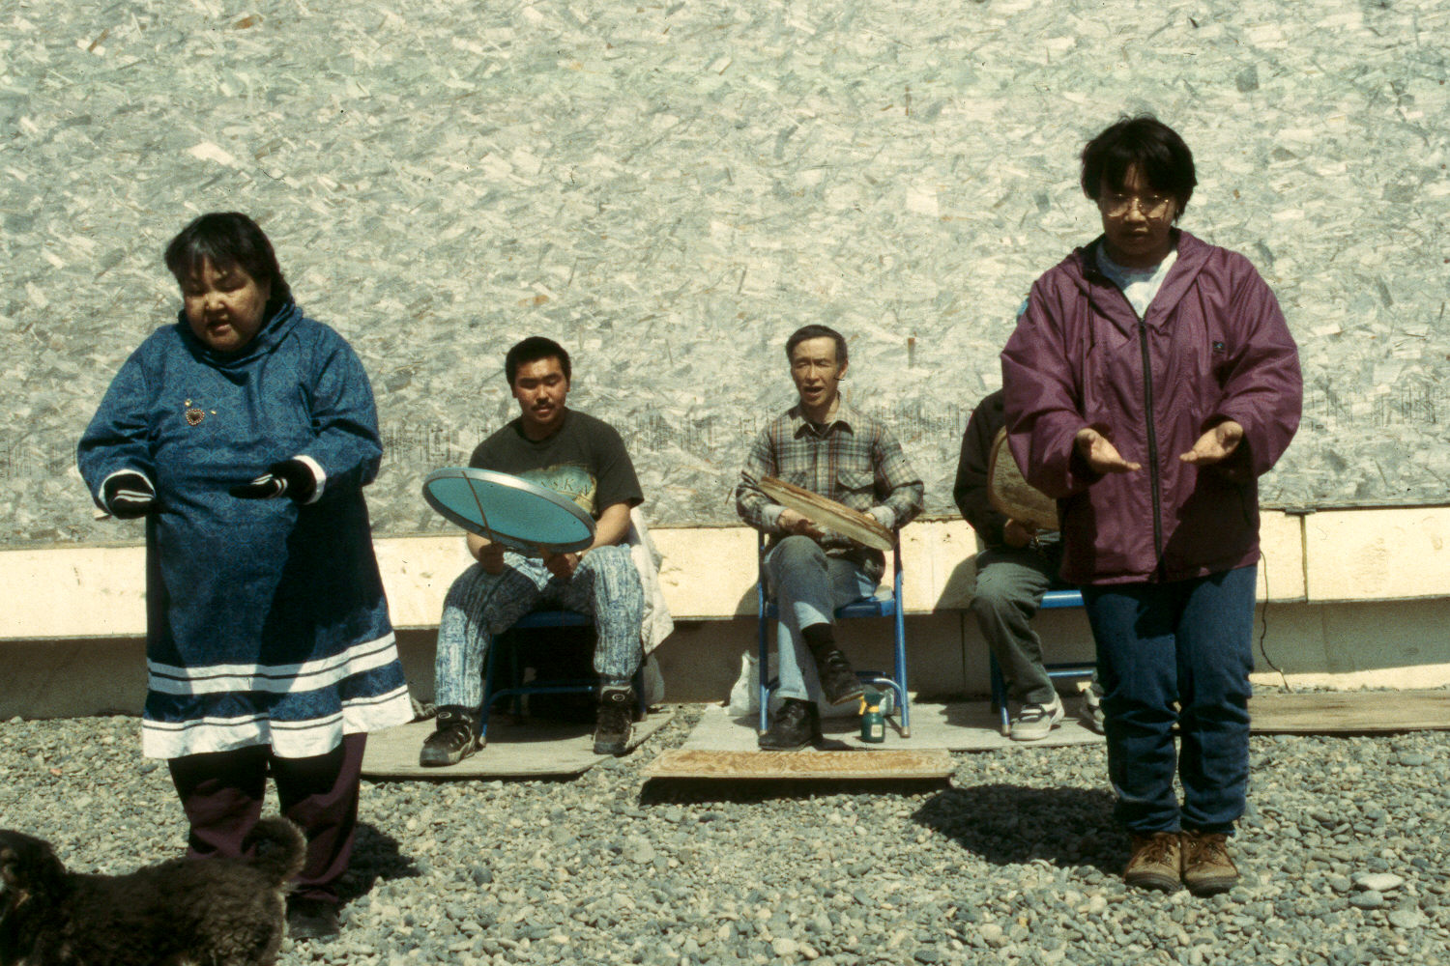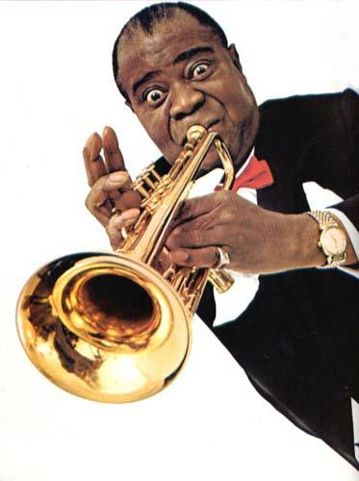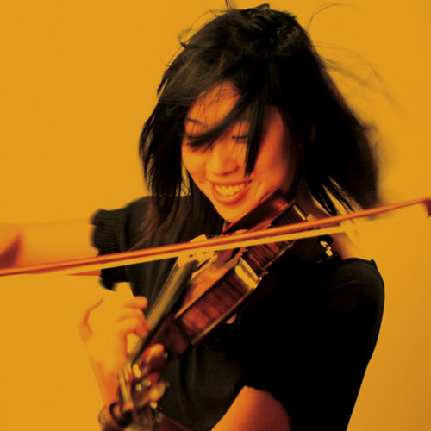

Tentative* Class Schedule:
Week Dates Topics Readings/Assignments Due

1 Jan 16-19 (No class Mon) Introduction to the Course & Syllabus Review. Clayton, Intro, Ch. 1
Anthropology, Culture, Bio/Ethnomusicology. Paper 1 due Friday

2 Jan 22-26 Origins of Music: Early Evidence, Basic categories of Clayton, Chs. 2 & 3
Musical Expression. Anthropology, Musicology, and History. Paper 2 due Wednesday

3 Jan. 29-Feb. 2 Music in Primary State Culture Areas and Eras. Clayton, Chs. 4 & 5
Categorization and Comparison. Paper 3 due Wednesday

4 Feb 5-9 Music in Primary State Culture Areas and Eras. Clayton, Chs. 6 & 7
. Music in Everyday Life. Paper 4 due Wednesday

5 Feb 12-16 Communication through Music Clayton, Chs. 8, 9
Music in Psychology and Creativity. Paper 5 due Wednesday

6 Feb 19-23 Music in Worship and Ritual Clayton, Chs. 10 & 11
Historical (Ethno)Musicology. Paper 6 due Wednesday

7 Feb. 26-Mar 2 History and Storytelling through Music Clayton, Chs. 12 & 13
Social History as It Relates to Music. Paper 7 due Wednesday

8 Mar 5-9 Review for Mid-Term Exam. Study for Mid-Term Ex
Mid-term Exam due Wednesday. Write & Submit Essays

9 Mar 12-16 Music in Healing and Therapy Clayton, Chs. 14 & 15
Music and Emotion, Musical Analysis Paper 8 due Wednesday

10 Mar 19-23 Spring Break!!!! None

11 Mar 26-30 Music, Sex, and Gender Clayton, Chs. 16 & 17
Music as Performance. Paper 9 due Wednesday

12 Apr 2-6 Musical Instruments and Their Evolution. Clayton, Chs. 18, 19, 23

13 Apr 9-13 Presentations & Discussion. Presentation Preparation

14 Apr 16-20 Presentations & Discussion. Presentation Preparation

15 Apr 23-27 Remaining Presentations & Discussion. Clayton, Chs. 20, 21, 22
Music and Identity Paper 10 Wednesday

16 Apr 30-May 4 Course Windup: The Direction and Global Influence of Clayton, Chs. 24, 25, 26
Contemporary Western Music.

17 May 11 Final Examination due by Monday, 12:30 PM Study for Final Exam

*No schedule is fixed in stone, including this one. Unless otherwise specified by the instructor, however, readings and written assignments are due on the dates shown above. Bring your syllabus to each class meeting so that you can note requirement and schedule changes as the course evolves.
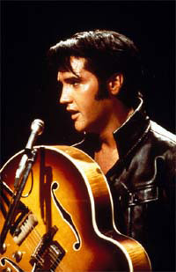
Instructor’s Note: I sincerely hope that you will learn something meaningful in this class, also that you will enjoy learning it. My job will be to present the subject matter in an interesting and meaningful way. Your job is to be an active participant in the learning process. I’ll do my part as best I can, but what you ultimately get out of this class is largely up to you. This is a foundation course, the knowledge from which you can build upon the rest of your college or university career, so approach it with that thought in mind. Welcome to what we—together—will do our best to make an exciting and rewarding semester.




